|  |
| --- |
| *[CS250]-Operating System Spring 2021-2022*  *Homework:1*  *Name: Pravin Arjun Shankhapal Roll no: 12041130* |

**Solution of problem A:**

Question 1:

1. There are 12 processors in the machine.

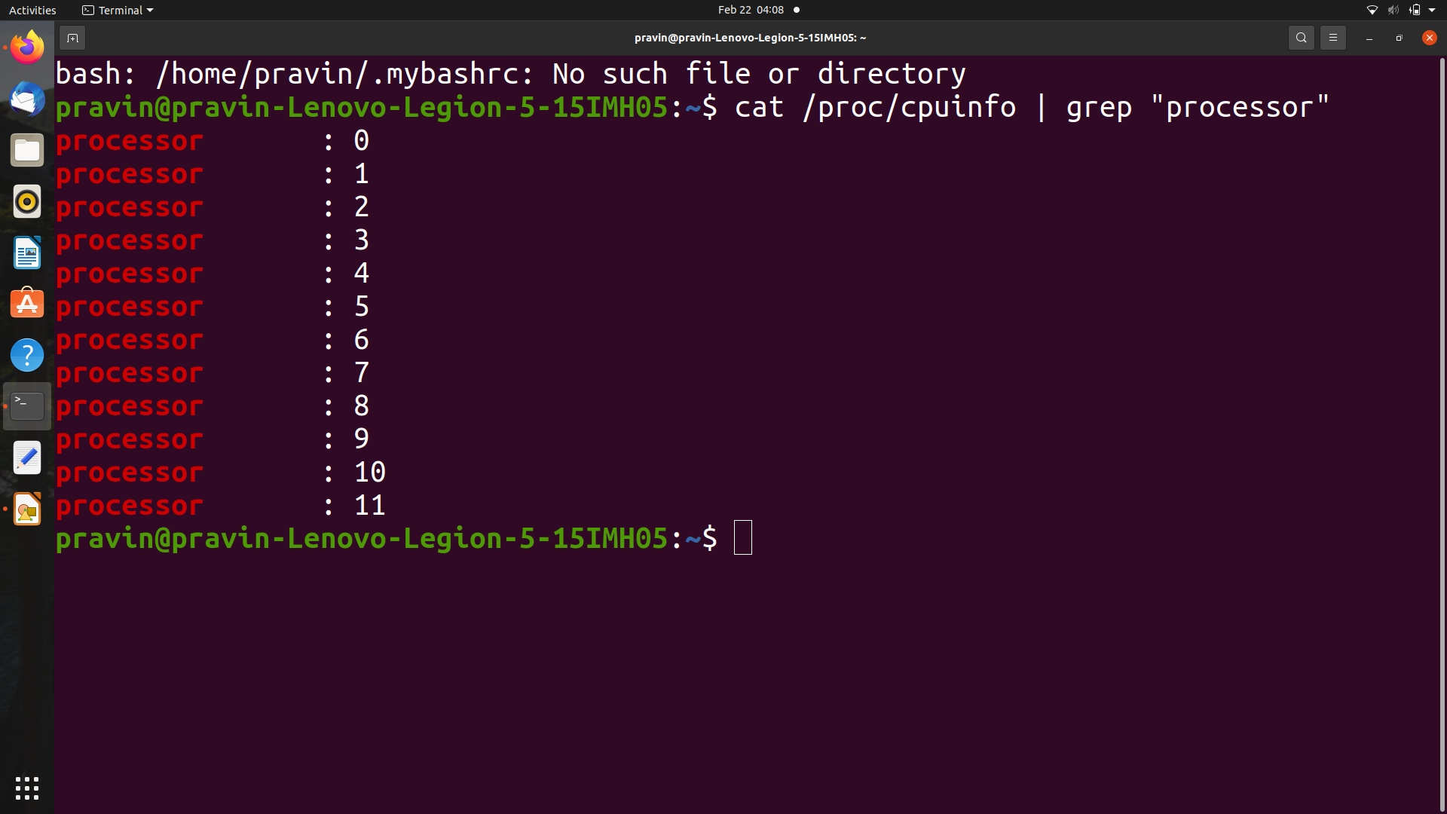

1. There are 39 bits physical and 48 bits virtual address sizes of each processor.

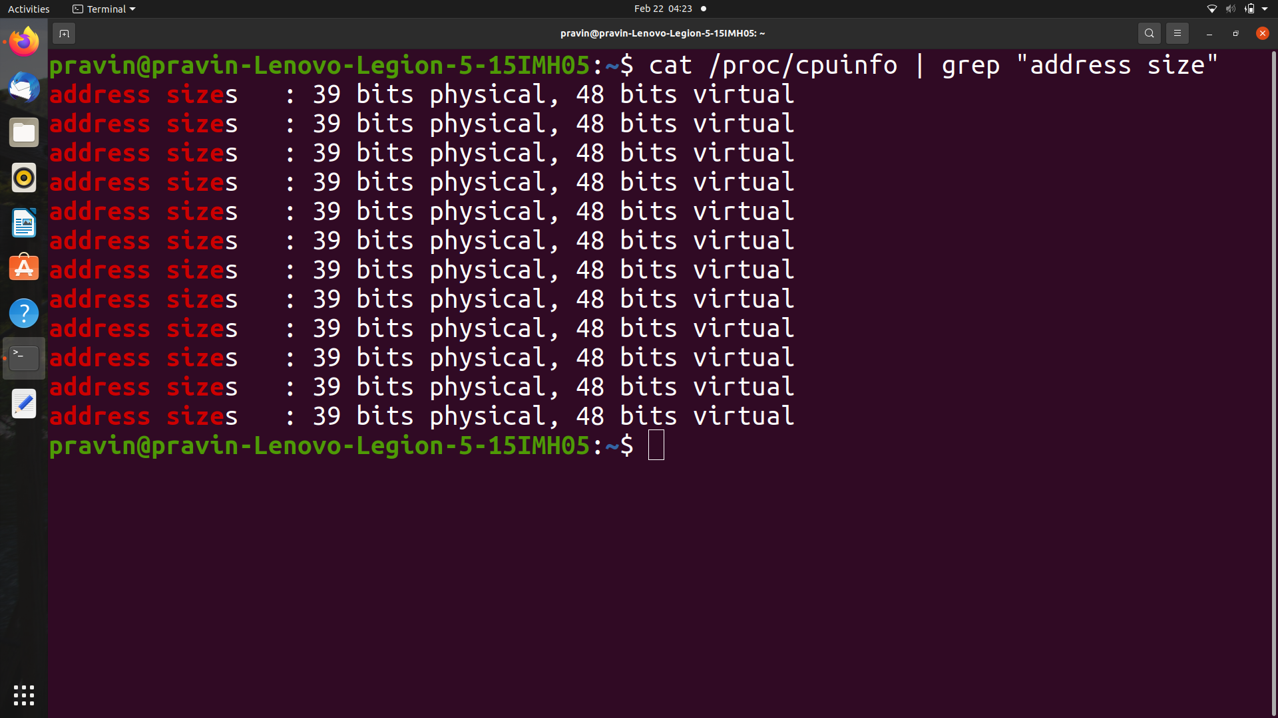

1. For most of the processors the frequency is 2600 MHz, except for two processors which have frequencies close to 800.

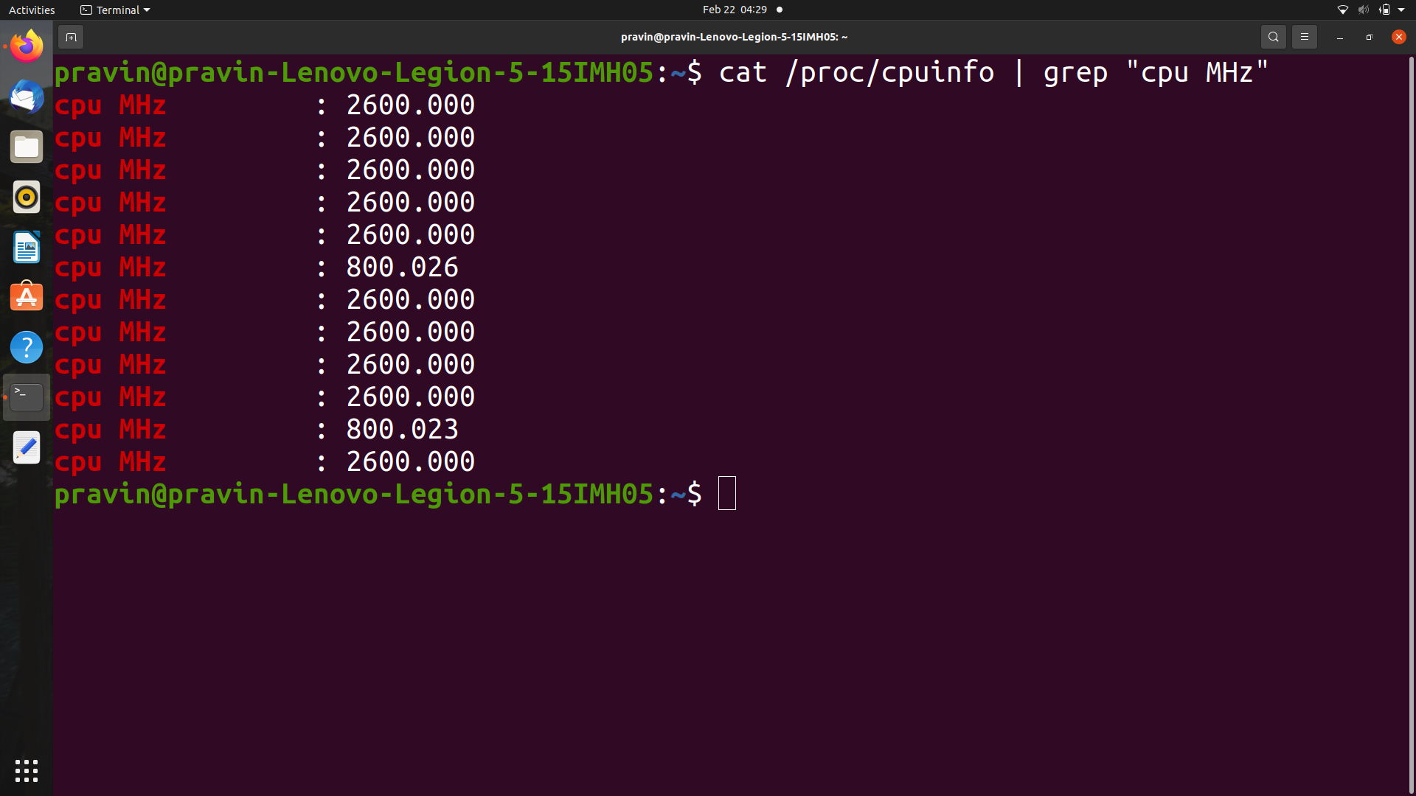

Question 2:

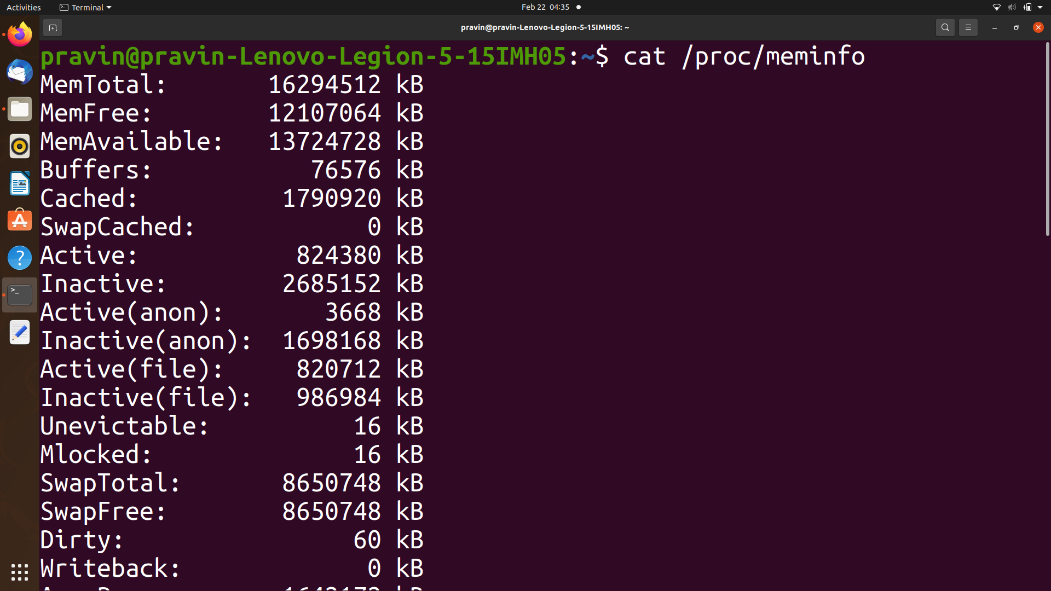

A. 16294512 kB

B. 12107064 kB

C. 76576 kB

Question 3:

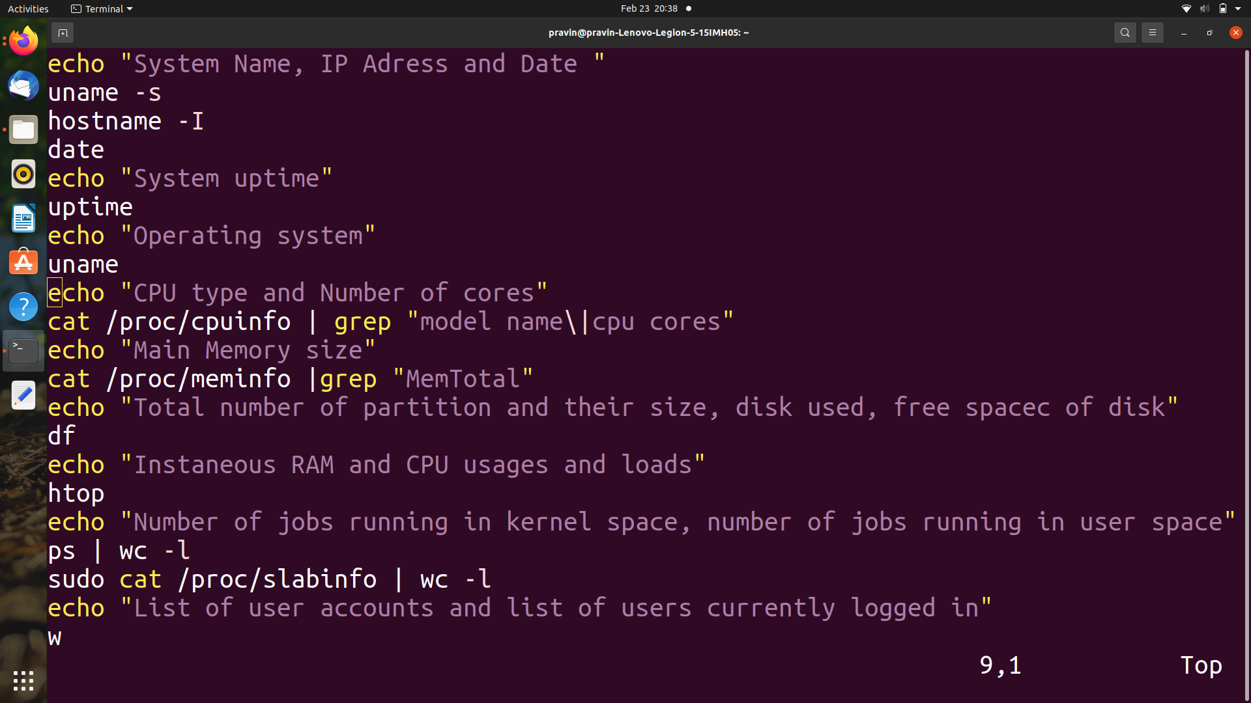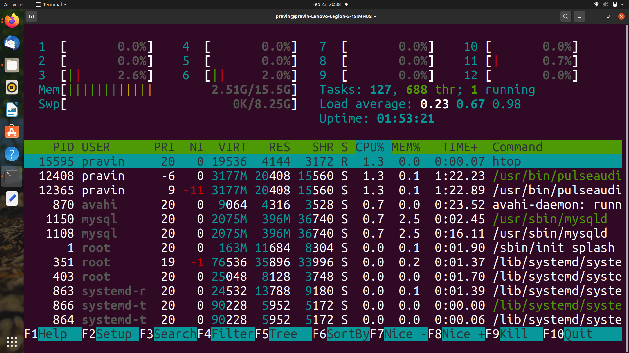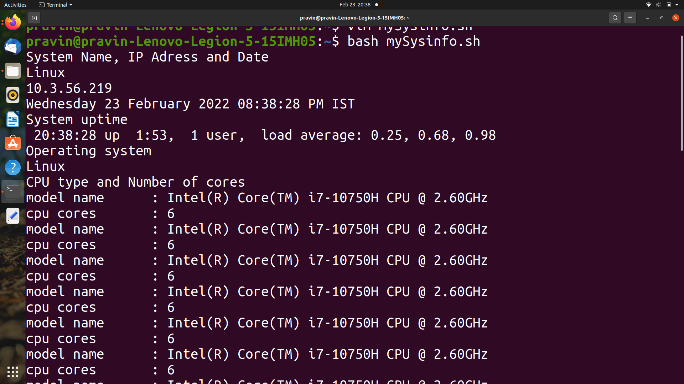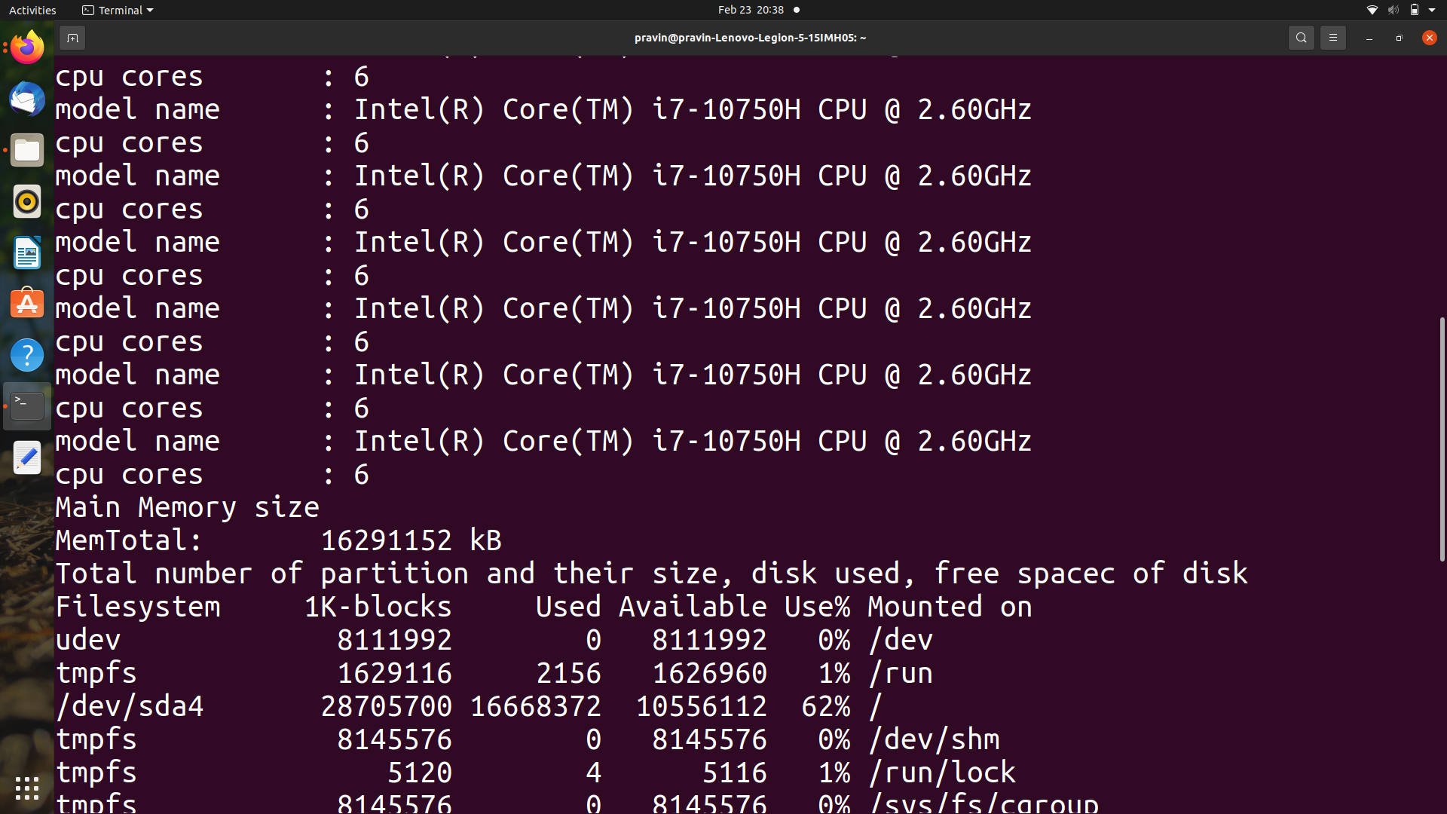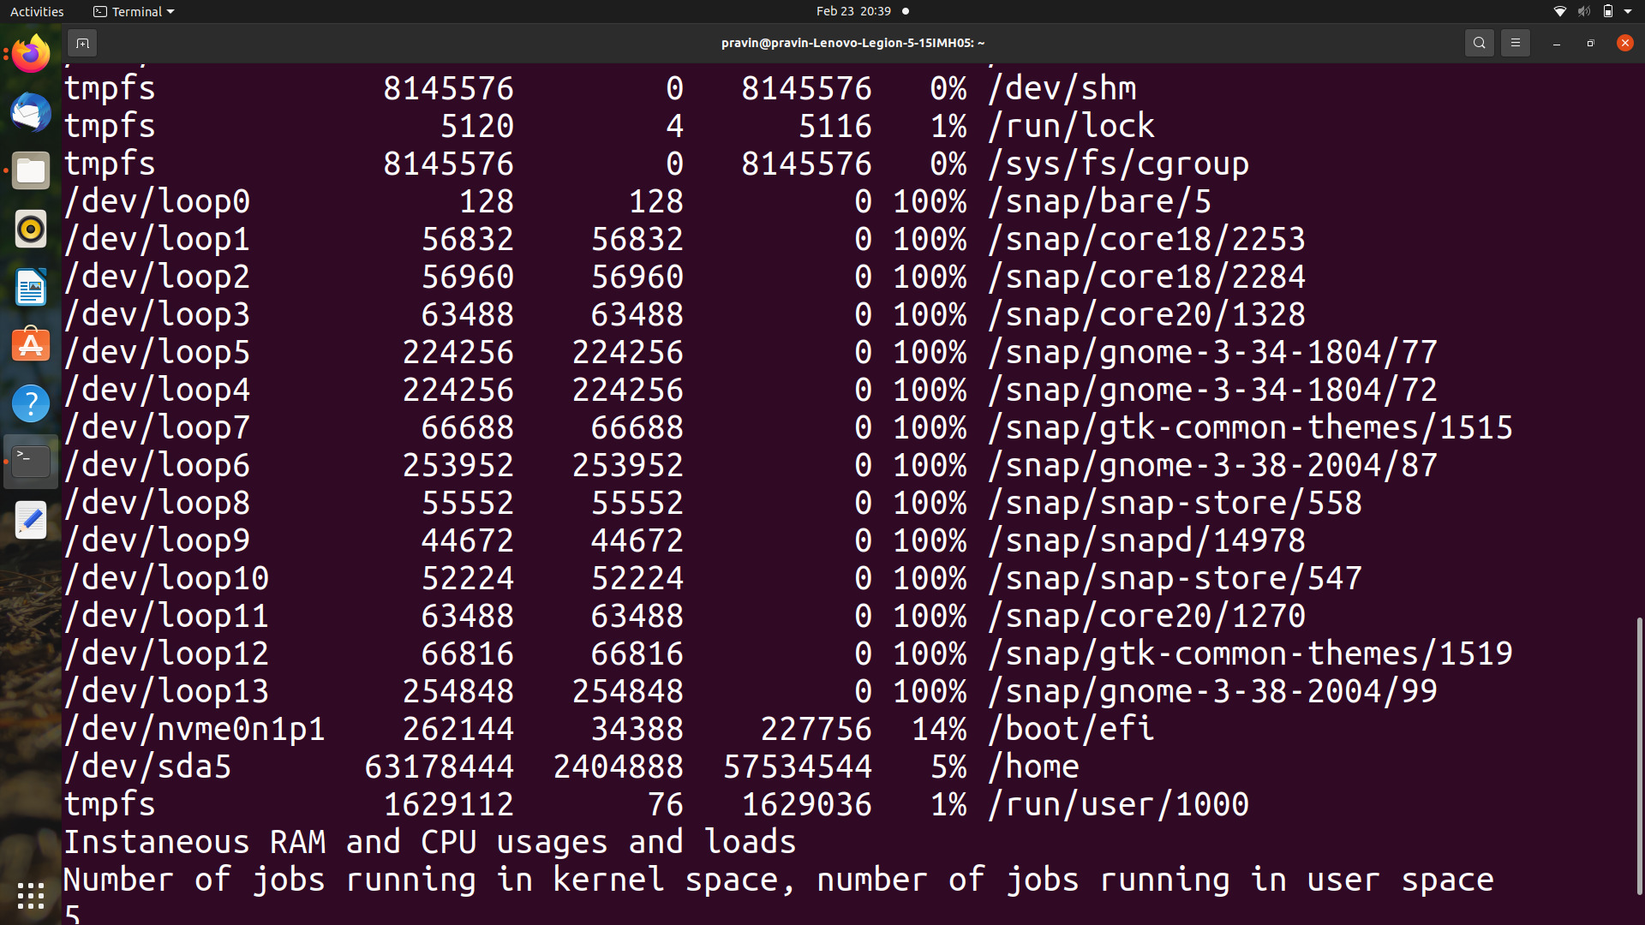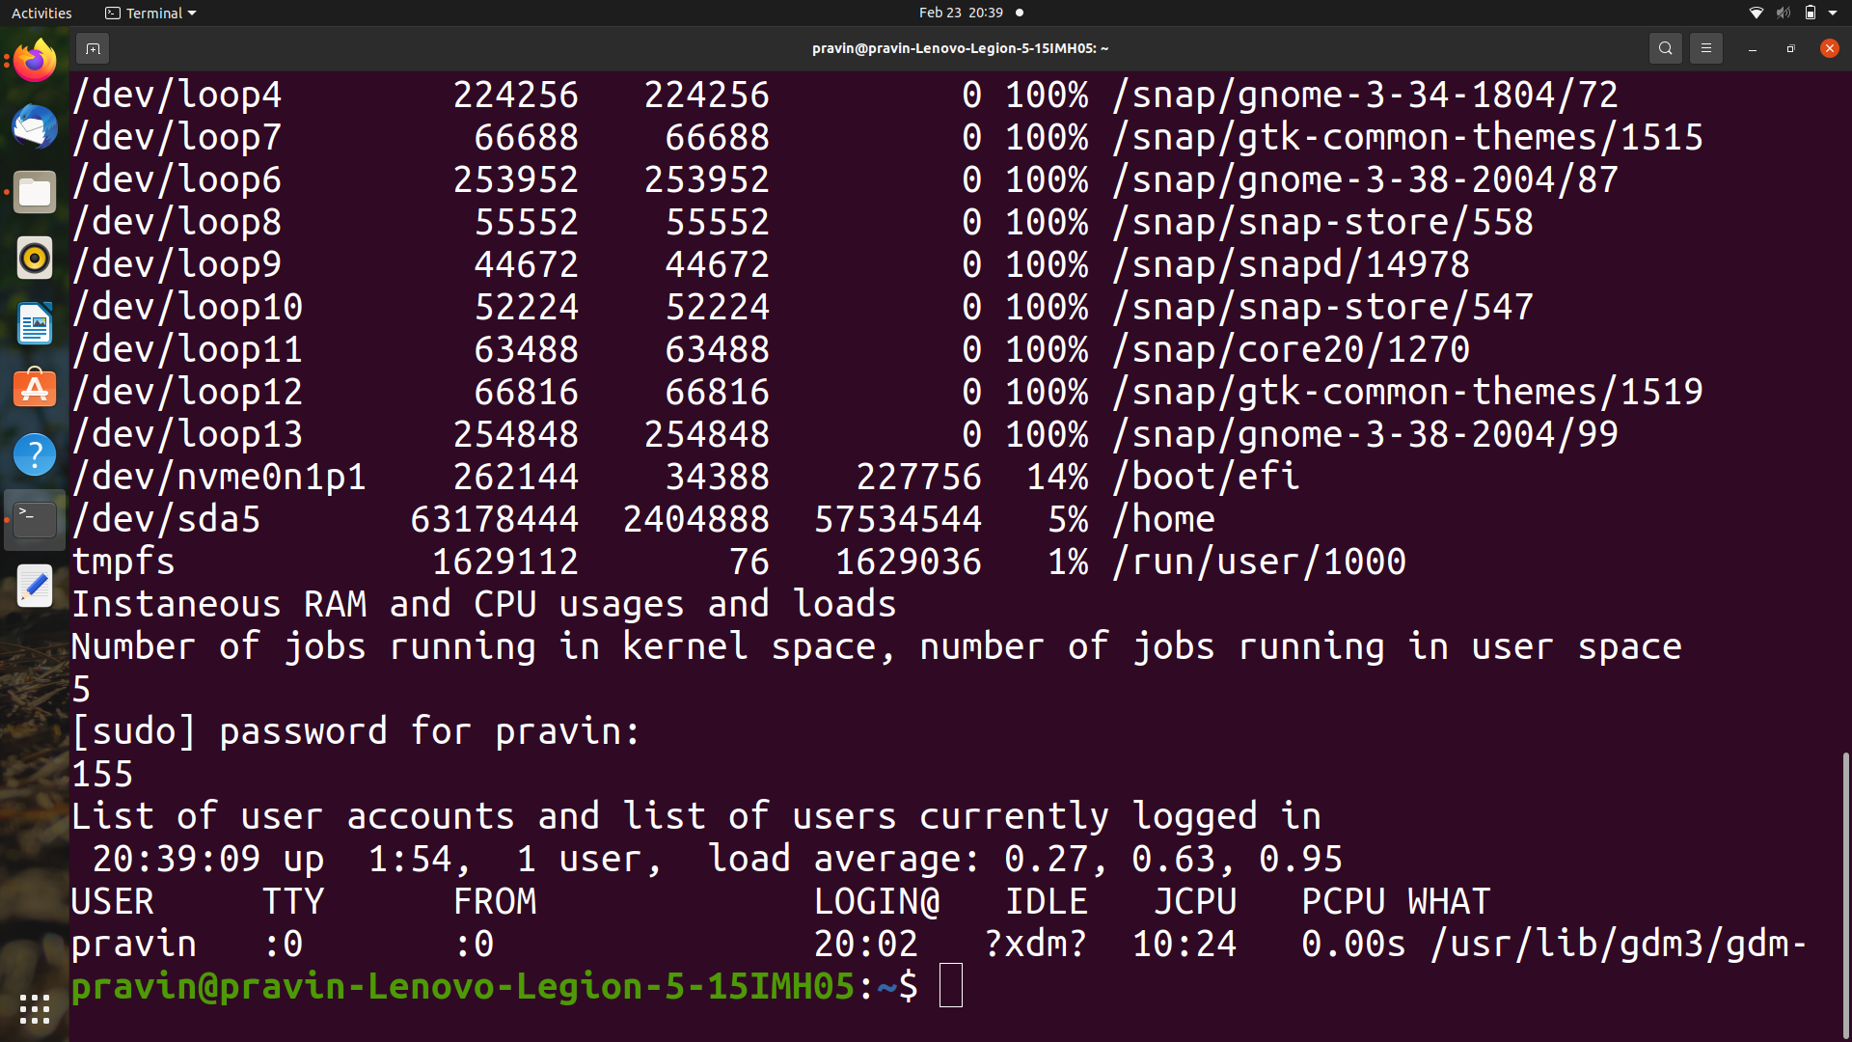

**Solution of problem B:**

Question 1:

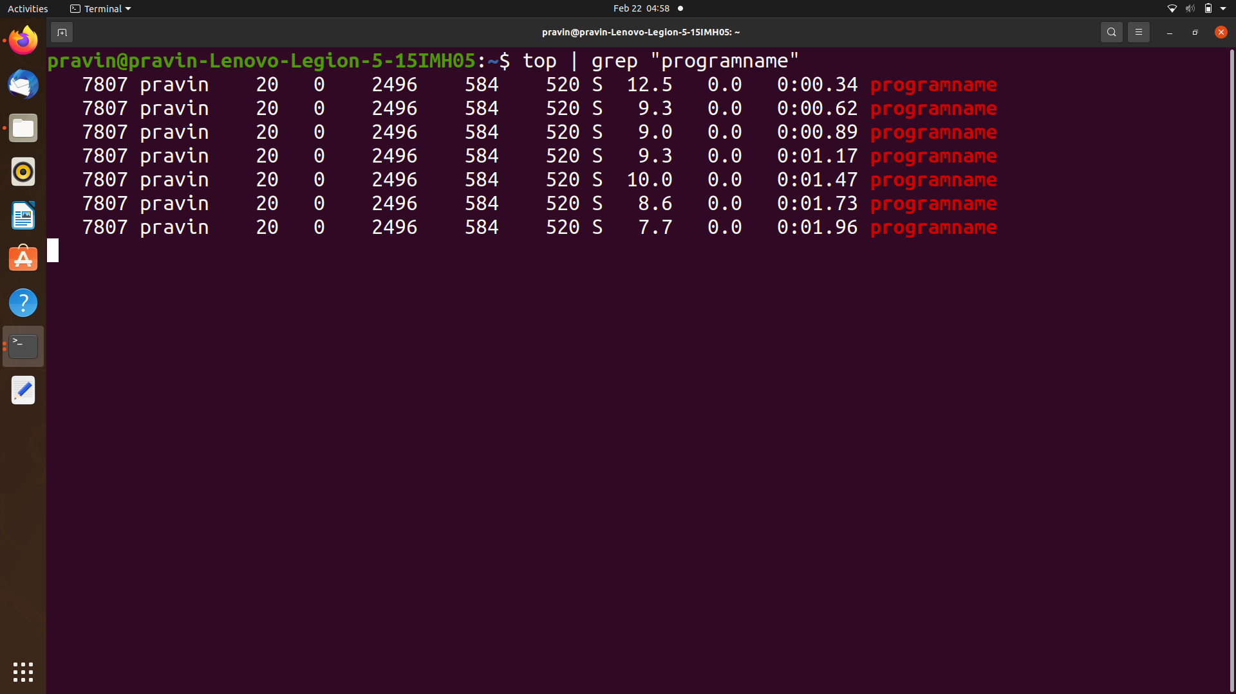

1. 7807
2. 12.5% cpu, 0% memory
3. 20
4. S (Sleeping)

Question 2:

1. ps
2. ps T
3. ps -c Process_name -o pid
4. ps - -ppid Process_number

Question 3:

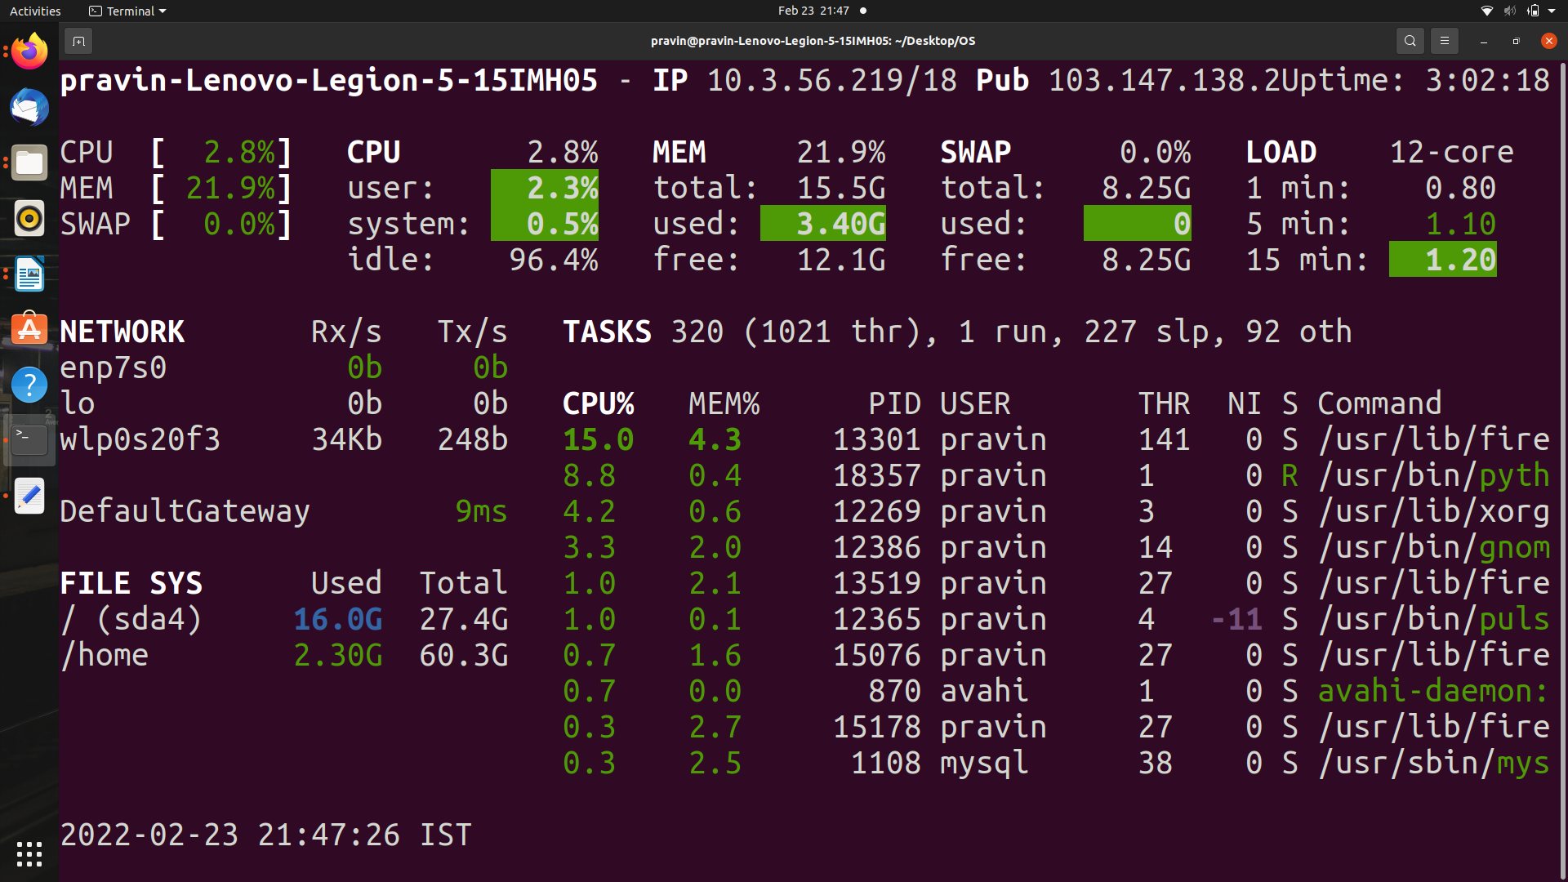

a . RAM, swap and free memory information. CPU information such as user related applications, system programs. Number of processes which are sleeping or running. Disk I/O read. Current date and time as well as IP of our local network and the public IP. Download, upload details. CPU, MEM, SWAP, LOAD, NETWORK, TASKS, FILE SYS are the details we can see.

b. Green - Everything is running well.

Blue - Caution

Violet - Warning

Red - Critical

c. We can see the top process which is consuming 15% of the total CPU consumption. The USER of that process is pravin as you can see in the above image. Memory consumption of that process is 4.3%. PID(Process ID) of that process is 13301. We can also see the state of the process is S. The Command is /usr/lib/fire

**Solution of problem C:**

Question 1:

After executing Boot_up1.bin:

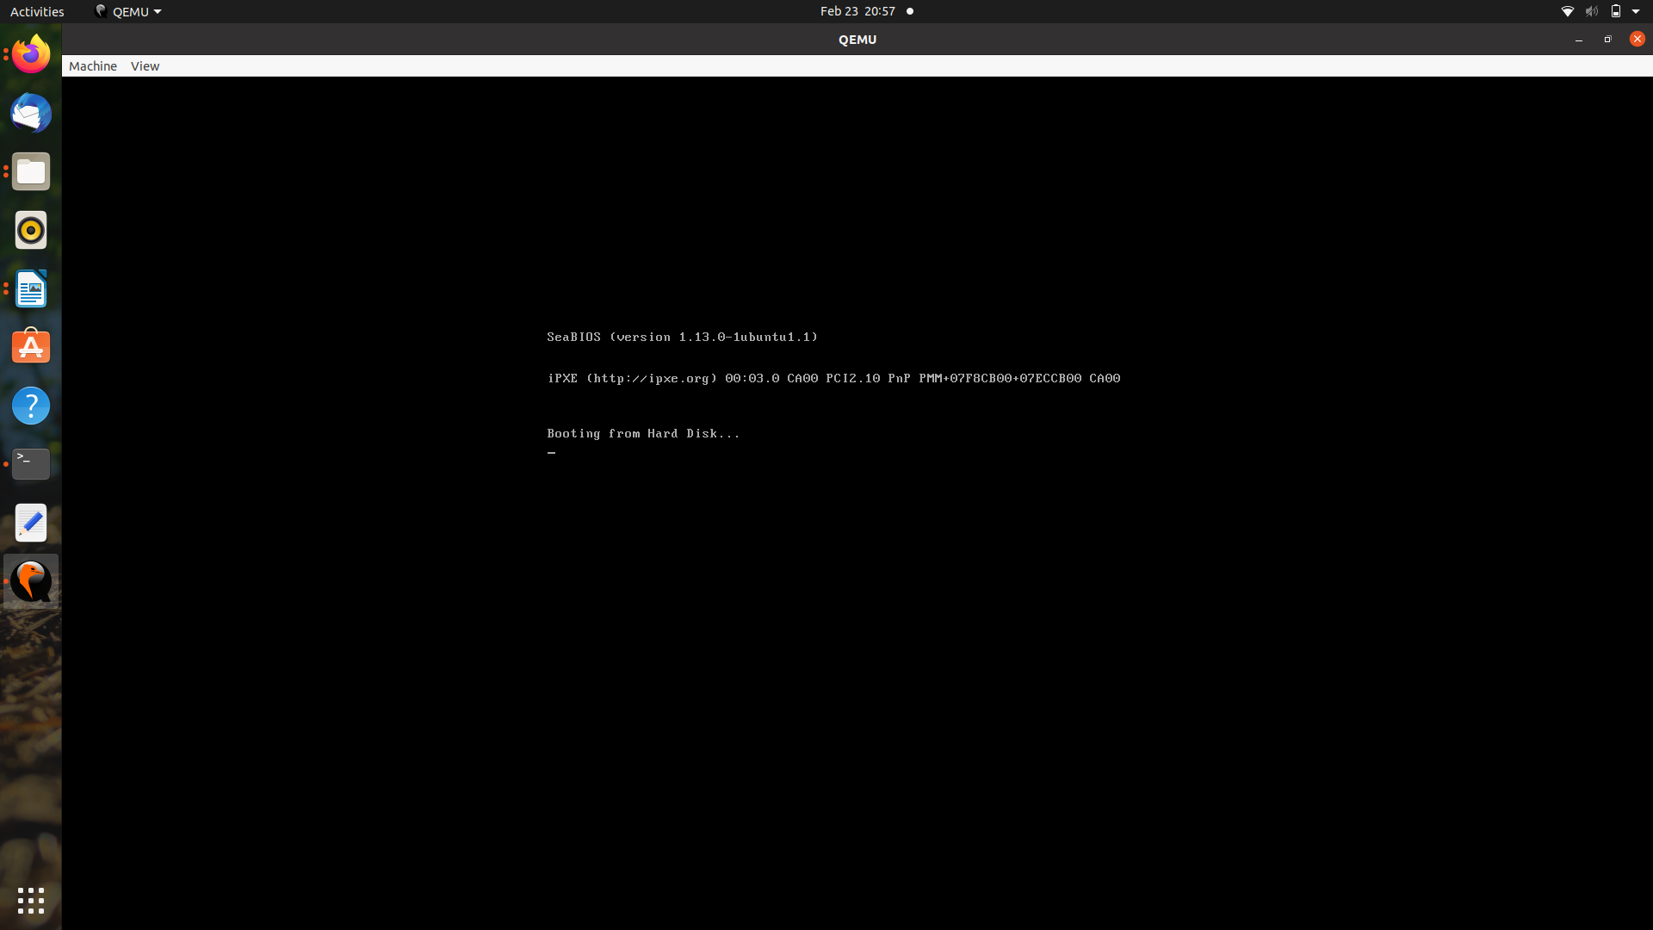

After executing Boot_up2.bin:

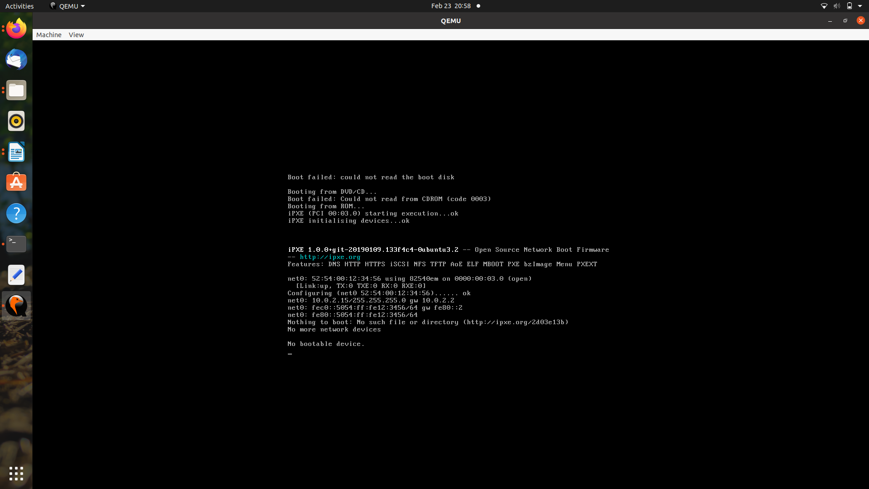

After executing hello.asm without changes:

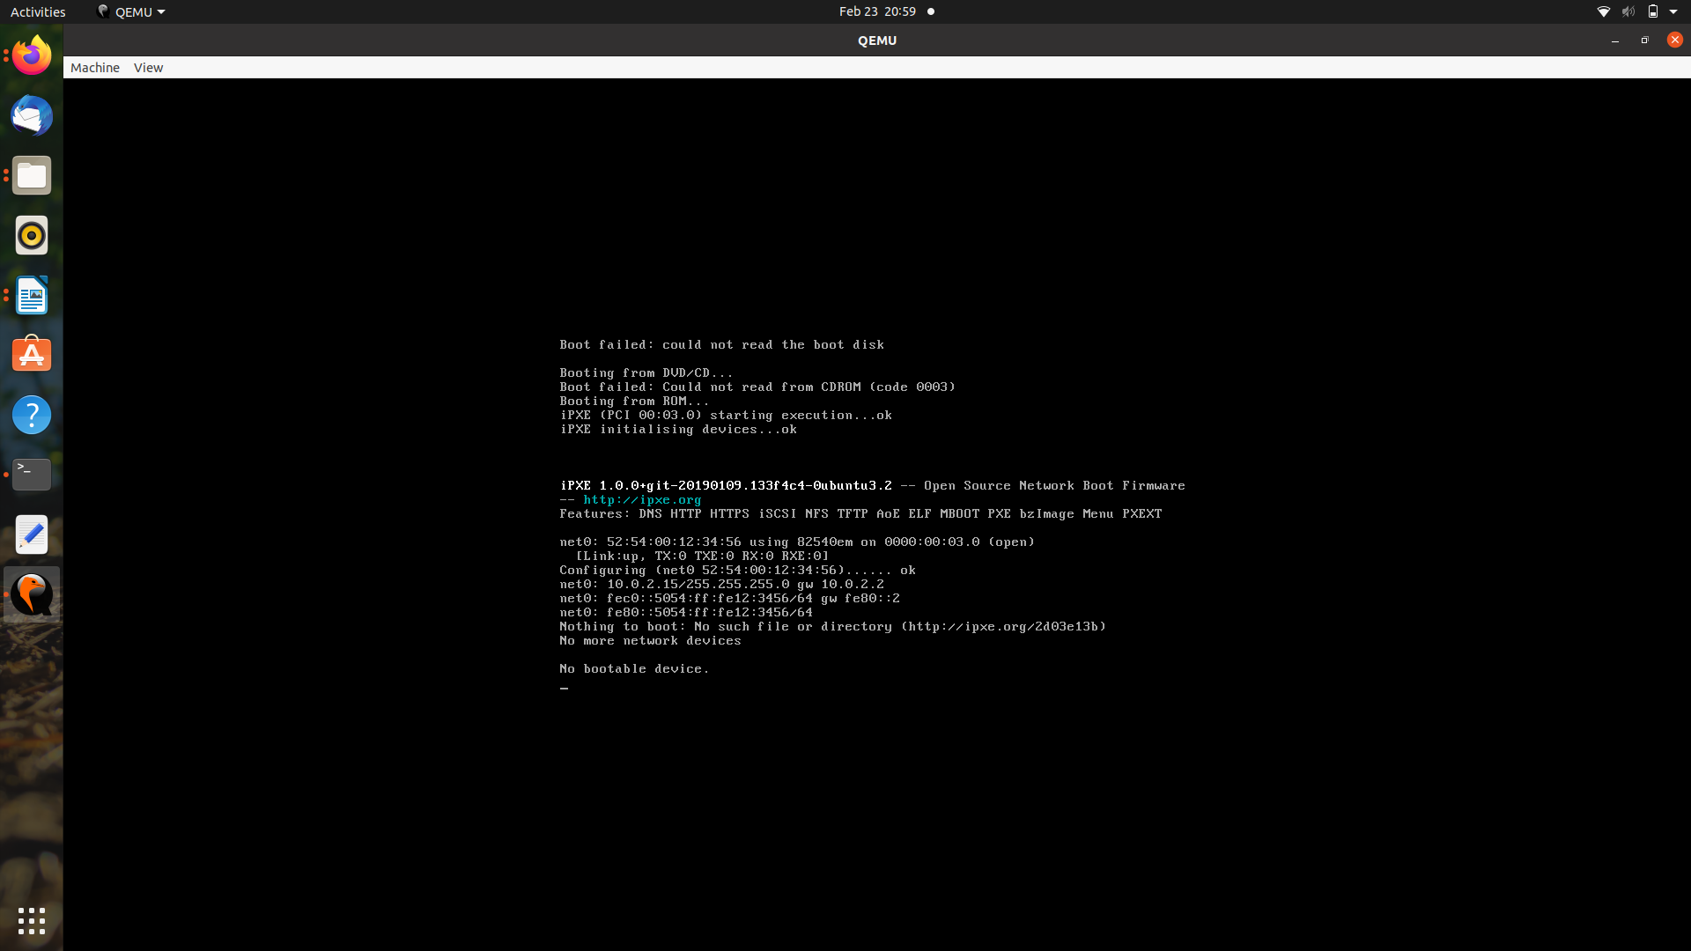

After modification of hello.asm and executing it we get:

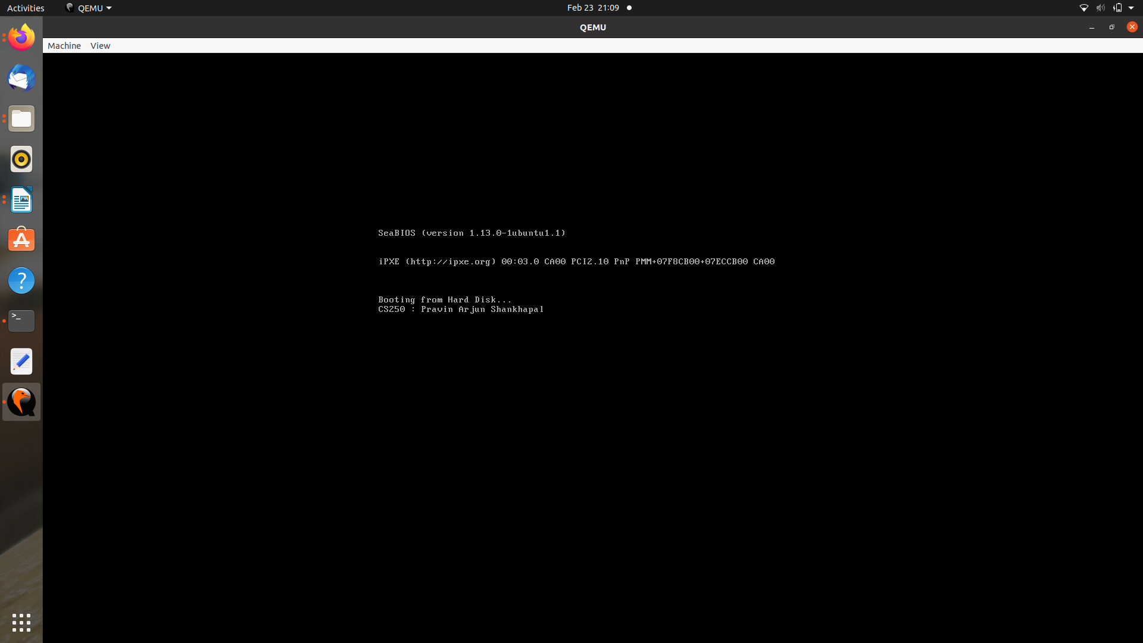

Boot_up1.asm contains the magic number, while the Boot_up2.asm does not contain the magic number. This is the only difference between Boot_up1.asm and Boot_up2.asm. When Boot_up1.asm is executed it finds the magic number while in the case of Boot_up2.asm it does not have the magic number thus leading to improper execution. The magic number lies in the final two bytes of the MBR (511 - 512), this section must contain the hex value AA55, which officially classifies it as a valid MBR.

Hence to run Boot_up2.asm we need to add the magic number at the end.

Now to run hello.asm we need to do two thing:

1. Add the magic number at the end of hello.asm.
2. Change the line 15 of hello.asm from “msg: db 0x30, 0” to “msg : db "CS250 : Pravin Arjun Shankhapal", 0”.

**Solution of problem D:**

Step 1. Installing some packages

*$sudo apt-get install git fakeroot build-essential ncurses-dev xz-utils*

*libssl-dev bc*

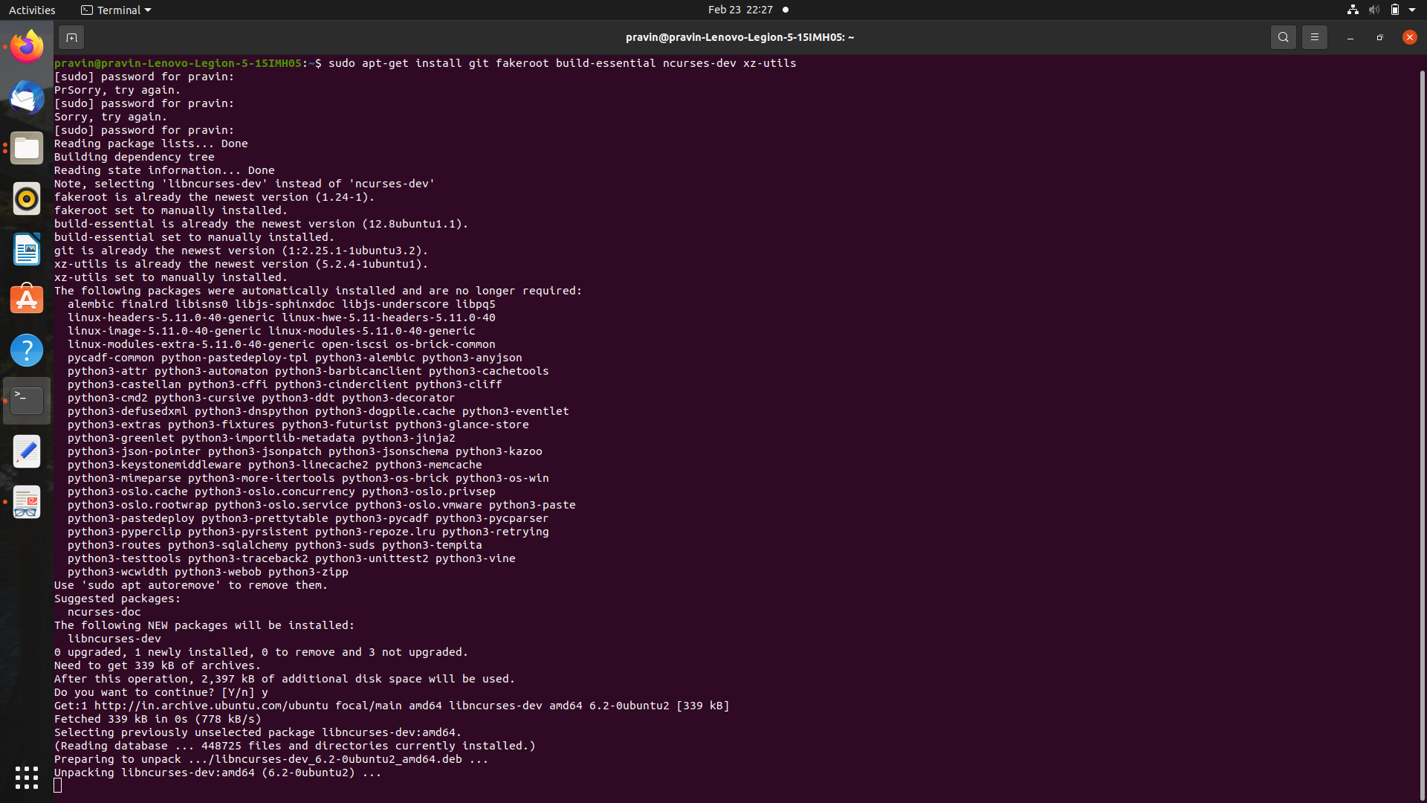

Step 2. Download the latest stable version from <https://www.kernel.org/> and extract zip file.

*$tar xf linux-5.16.10.tar.xz*

*$ cd linux-5.16.10*

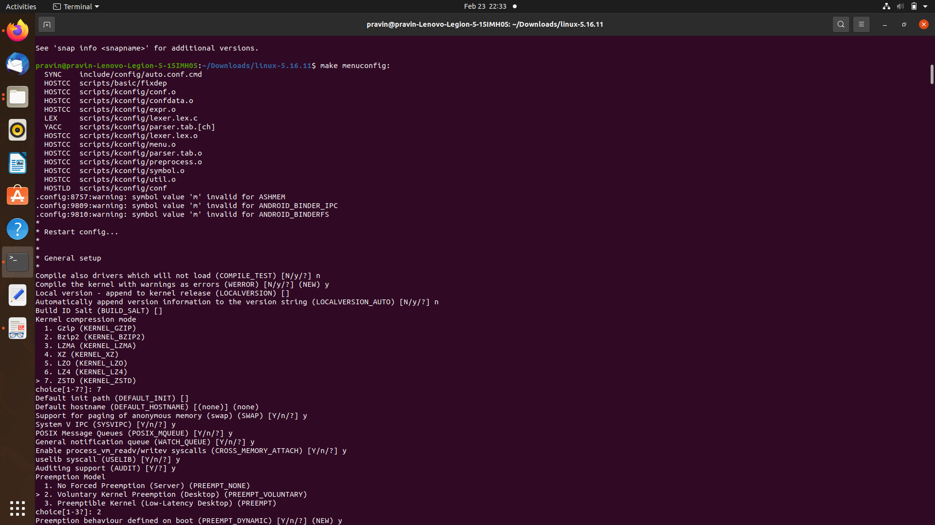

Step 3. Install the required compilers.

*$ make menuconfig:*

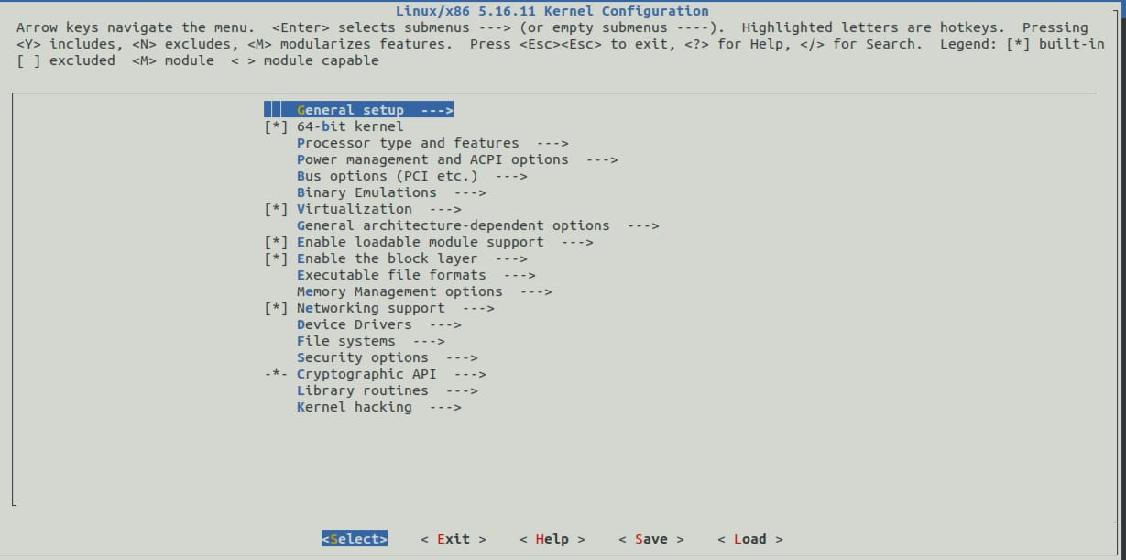

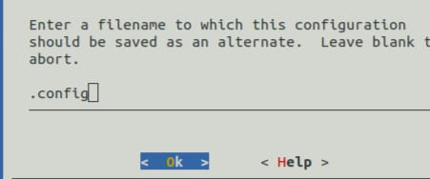

Step 4. Compile the linux kernel.

*$ make:*

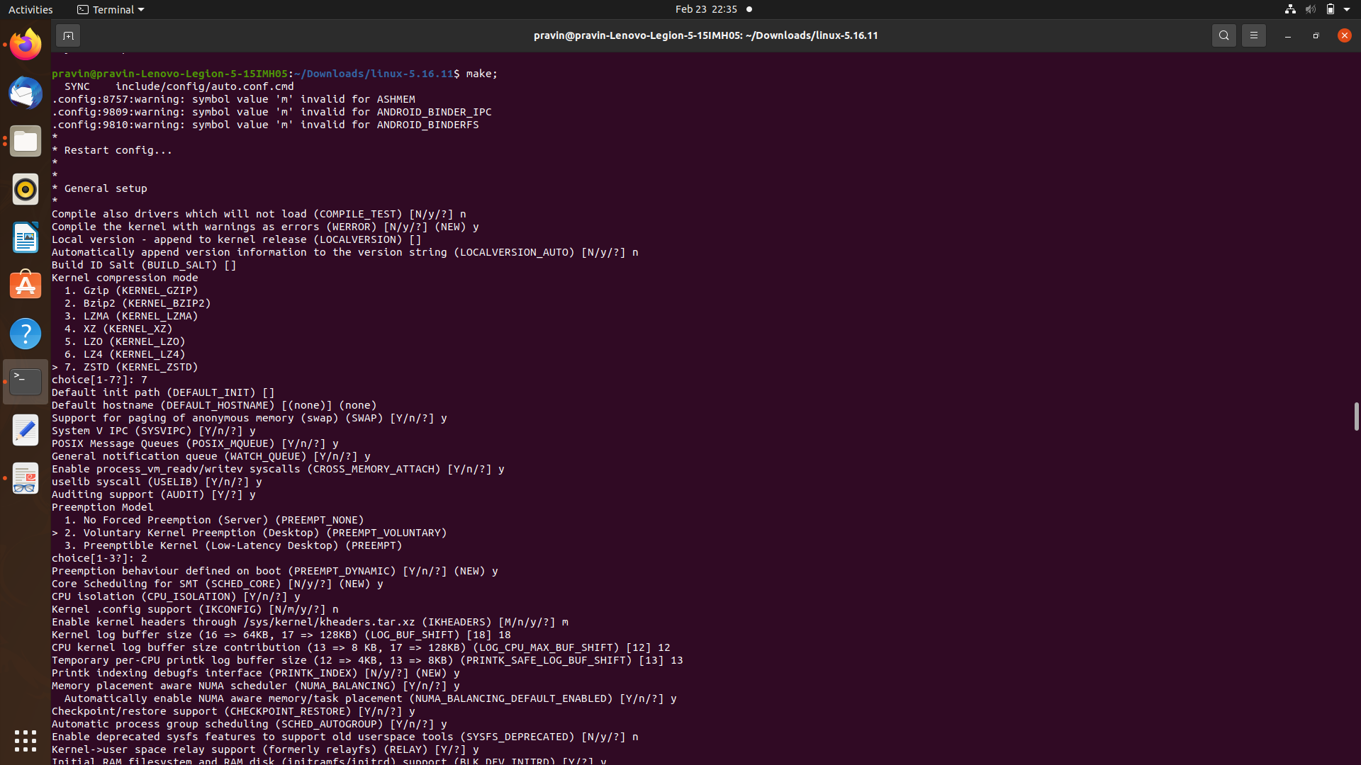

Step 5: Install kernel modules.

*sudo make modules_install*

*sudo make install*

*After doing this steps*

*Run command uname -r*

*It was running till submission which will get installed after that.*